Обожаемой группе
посвящается
From  Lady Ice

Arcadia
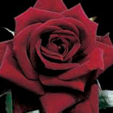

А также её идейным вдохновителям

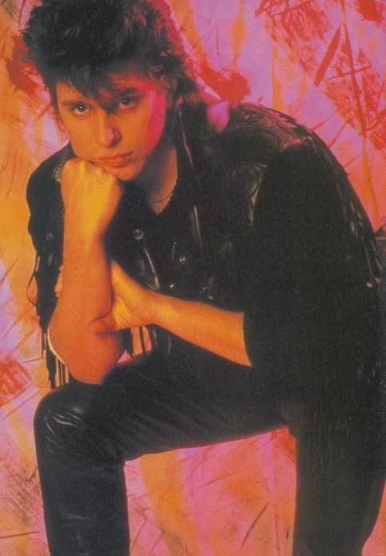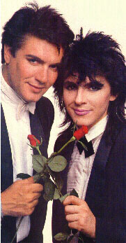

Arcadia was the pop group formed in 1985 by Simon Le Bon, Nick Rhodes and Roger Taylor of
Duran Duran, during a break in that band's schedule. However, Roger Taylor appeared in only
a few band photographs and in none of the music videos, and stated he was only to be
involved in the recording side of the project (he also had minor involvement in The Power
Station, the other Duran Duran splinter group).
Arcadia recorded just one album, the platinum-selling So Red the Rose. It peaked at number
23 on the US album chart, and featured the Top 40 singles "Election Day," "The Flame," "The
Promise," and "Goodbye is Forever." One famous review described So Red the Rose "the most
pretentious album ever made"[citation needed], while All Music Guide called it "the best
album Duran Duran never made"[1]. Musicians who contributed to the album include guitarists
David Gilmour (Pink Floyd) and Carlos Alomar, pianist Herbie Hanthingy, Sting (who provided
backing vocals on "The Promise"), Grace Jones (who provided backing vocals on "The Flame"
and on "Election Day") and bass player Mark Egan (Pat Metheny Group) who added his
distinctive sound to the LP (in particular to "El Diablo" and "Lady Ice") and David Van
Tieghem, an incredible percussionist from New York.
The band also recorded the single "Say the Word" for the Playing For Keeps movie soundtrack.
Arcadia continued the Duran Duran tradition of a slick image, tasteful fashions and
hair-dos. For the Arcadia incarnation of their ever-changing band aesthetic, Rhodes, Le Bon,
and Roger Taylor donned an upmarket 'gothic' look of black tuxedos, vintage formal wear, and
bow ties. The three also dyed their hair black, as seen when they performed (as Duran Duran,
with Andy and John Taylor) at the 1985 Live Aid concert in Philadelphia.
Arcadia did a variety of promotional appearances on television, but never toured. Arcadia
was dissolved in late 1986 when Duran Duran re-formed with LeBon, Rhodes, and bassist John
Taylor to record Notorious. Drummer Roger Taylor retired from the music business for almost
20 years shortly after the release of the Arcadia album, but returned to rejoin the original
Duran Duran line-up in 2001.

